Erik Oatman
Online Clin Corr
Wk 5 LTC
Dr. Davidson

Second HW Assignment:

1) Analgesia in CKD: How to treat it/what to avoid:
When it comes to pain management in CKD, drug selection is based on the nature of the pain (nociceptive vs. neuropathic pain), the severity of the pain, and the severity of the CKD.
Nonpharmacologic approaches such as CBT are generally the same among CKD and non-CKD patient populations, and should be considered first line in managing chronic pain. Unfortunately due to frailty, lack of cognitive ability, and time and energy devoted to dialysis and other health care demands, CBT and other forms of nonpharmacologic pain management might not be a practical option for elderly CKD patients, but it should be considered in those individuals where appropriate.
Pharmacologic treatment of pain in mild to moderate CKD (>30 mL/min/1.73m²): With the exception of NSAIDs, analgesia is similar to those of non-CKD patients. Low-dose NSAIDS are still acceptable for pts with GRF >45 ml/min/1.73 m² but are reserved for acute pain, not chronic.
Pharmacologic treatment of pain in advanced CKD (<30 mL/min/1.73 m²): UpToDate’s pharmacologic approach is adapted from the WHO’s analgesic ladder, involving a cautious, stepwise approach to analgesia based on severity of pain. Tier 1 pain (mild) is treated with nonopioid analgesia. Tier 2 pain (moderate) is treated with weak opioids +/- nonopioid agents. Tier 3 pain (severe) is treated with strong opioids. It is modified in that codeine is not used and weaker opioids are foregone in favor of strong opioids.
For nociceptive Pain:
Acetaminophen is standard first line analgesia for nociceptive pain in CKD patients. It is relatively safe to give the same full doses to CKD as you would non-CKD patients.
Patients who don’t respond to acetaminophen are given opioids with acetaminophen. Preferred opioids include hydromorphone, fentanyl, methadone, and buprenorphine. Oxycodone may be used but it’s considered second-line. Opioids must be used with caution, and normal-release (short-acting) are preferred over modified-release (long-acting). Oral or transdermal agents, rather than parenteral routes, should be used.
Neuropathic Pain:
Antiepileptic drugs (AED’s) such as gabapentin and pregabalin are first-line for neuropathic pain. Efficacy and toxicity profiles of both are similar, but gabapentin is generally less expensive.
Tricyclic Antidepressants (TCA’s) such as amitriptyline are second-line for CKD patients whose neuropathic pain is not relieved by the maximum doses of AED’s. Other AED’s such as doxepin, imipramine, nortriptyline, and desipramine have been used with success.
Carbamazepine is a tricyclic compound related to TCA’s and may also be used. It does not require dose adjustment in CKD.
Methadone may be effective for severe, refractory neuropathic pain.
Mixed Nociceptive & Neuropathic Pain:
Usually start with acetaminophen with gabapentin or pregabalin. Titrate the AED first before considering adding a strong opioid. The preferred opioid is methadone.
Drugs that should be avoided:
Generally do not use NSAID’s, codeine, tramadol, dextropropoxyphene, morphine, meperidine/pethidine, or propoxyphene among patients with advanced CKD

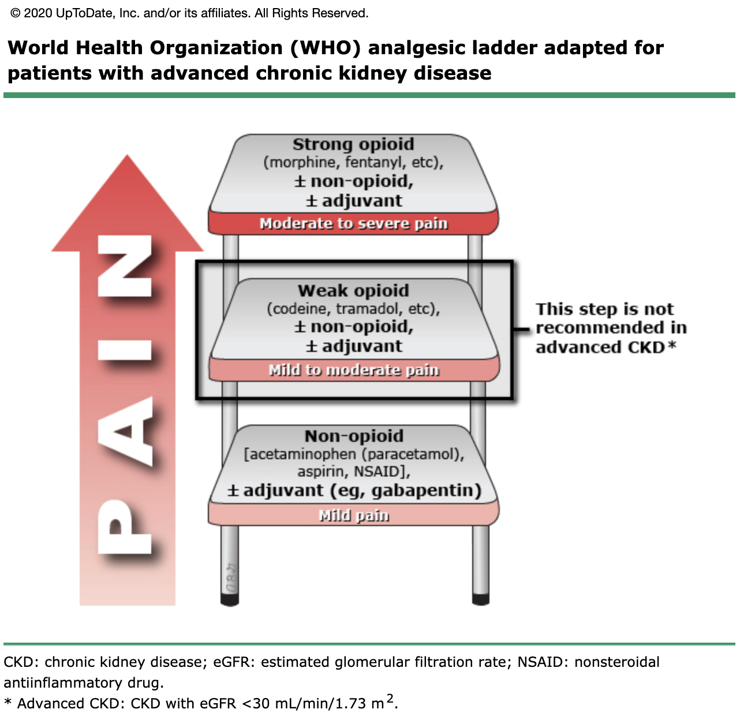

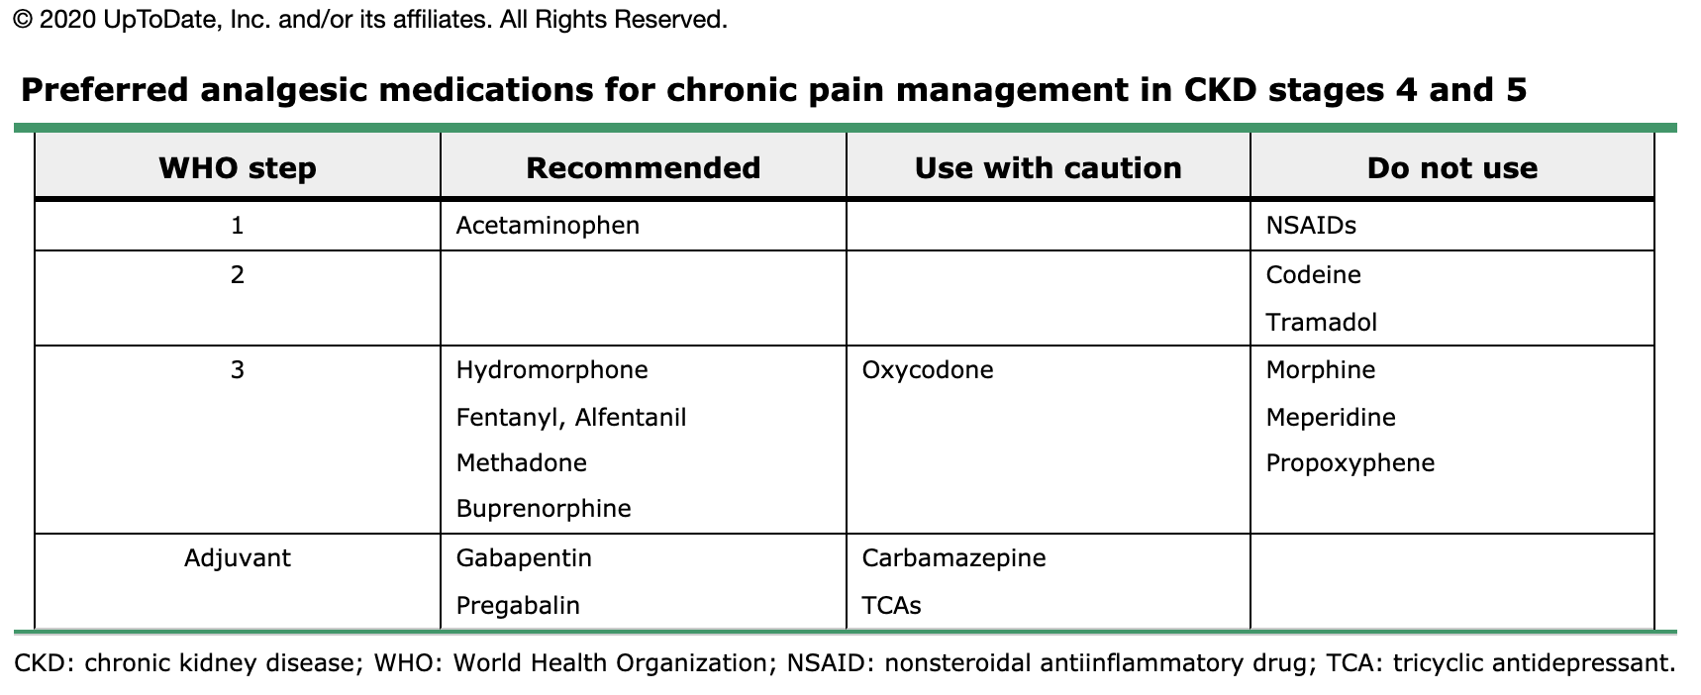

Source: https://www-uptodate-com.york.ezproxy.cuny.edu/contents/management-of-chronic-pain-in-advanced-chronic-kidney-disease?search=analgesia%20in%20ckd&source=search_result&selectedTitle=1~150&usage_type=default&display_rank=1#H3890441370

2) OTC drugs to avoid in CKD:
- NSAIDS: ibuprofen, naproxen, and aspirin. Check the ingredients on the labels of cold and cough remedies for NSAID’s as they are often included.
- Decongestants: pseudoephedrine, especially in pts with HTN
- Antacids and laxatives with magnesium, phosphorus, and Aluminum such as Mylanta, Milk of Magnesium, Amphogel, and Fleets products
- Alka seltzer or baking soda products for indigestion
- Herbal medicines and remedies
- Vitamin and diet/food supplements
- Salt substitutes that contain potassium
Source: https://unckidneycenter.org/files/2017/10/ckd_medicines.pdf

